Rules: Multiplying and Dividing Pos. and Neg. Numbers

* If the signs are the same the answer is positive

9 x 9 = Positive number

(-3) / (-4) = Positive number

* If the signs are different the answer is negative

10 x (-7) = Negative number

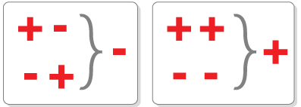 (-5) / 6 = Negative number